***A Mini project Synopsis on***

### AQI Forecast

**T.E.- Computer Science and Engineering (Data Science)**

### Submitted By

### Krish Jaiswal 21107039

### Khushi Kadam 21107031

### Shravani Kulkarni 21107063

### Vedant Mayekar 22207007

**Under The Guidance Of**

### Prof. Vaibhav Yavalkar



#### DEPARTMENT OF CSE (DATA SCIENCE)

**A.P. SHAH INSTITUTE OF TECHNOLOGY**

G.B. Road, Kasarvadavali, Thane (W), Mumbai-400615 UNIVERSITY OF MUMBAI

**Academic year:2023-24**

## CERTIFICATE

This to clarify that the Mini Project Report on **AQI Forecast** has been submitted by **Krish Jaswal(21107039),Khushi Kadam(21107031),Shravani Kulkarni(21107063),Vedant Mayekar(22207007)** who are a Bonafede students of A. P. Shah Institute of Technology, Thane, Mumbai, as a partial fulfilment of the requirement for the degree in **CSE(DATA SCIENCE)**, during the academic year **2023-2024** in the satisfactory manner as per the curriculum laid down by University of Mumbai.

Mr. Vaibhav Yavalkar Guide

Prof. Anagha Aher Dr. Uttam D. Kolekar

Head Department of CSE (Data Science) Principal

External Examiner(s) 1.

2.

Place: A.P. Shah Institute of Technology, Thane Date:

## TABLE OF CONTENTS

Abstract

1. Introduction 1
   1. Purpose 1
   2. Problem Statement 2
   3. Objectives. 3
   4. Scope 5
2. Literature Review 7
3. Proposed System 8
   1. Features and Functionality 9
4. Requirements Analysis 11
5. Project Design. 14
   1. Use Case diagram 14
   2. DFD (Data Flow Diagram) 14
   3. System Architecture 15
   4. Implementation 15
6. Technical Specification 17
7. Project Scheduling 20
8. Results 22
9. Conclusion 23
10. Future Scope 24

Reference

# ABSTRACT

We present a groundbreaking method for predicting the Air Quality Index (AQI). We propose incorporating cutting-edge technologies to boost forecasting precision. Conventional AQI forecasting methods rely on past data and simple statistical models, delivering useful but restricted forecasts. Our method utilizes sophisticated techniques such as machine learning algorithms, atmospheric dispersion models, and data merging to attain unparalleled AQI forecasting accuracy. Critical system elements include advanced algorithms for identifying key factors, ensemble learning models, and integrating real-time data. This integration aims to enhance the accuracy and dependability of AQI predictions. Air quality is vital for health and the environment. Current ways of predicting air quality are not always accurate enough. Our new, advanced system uses the latest technologies to give more exact and reliable predictions. It combines machine learning, atmospheric science, and real-time data to help stakeholders take steps to reduce air pollution and protect people's health.

The traditional methods of predicting the Air Quality Index (AQI) have been valuable but limited in their accuracy and reliability. These methods typically rely on historical data and simplistic statistical models, offering useful but often constrained forecasts. However, with the advent of cutting-edge technologies, there's a significant opportunity to revolutionize AQI forecasting. By incorporating advanced techniques such as machine learning algorithms and atmospheric dispersion models, we can greatly enhance the precision of AQI predictions. Machine learning algorithms have the capacity to identify intricate patterns in data that might not be apparent through traditional methods, allowing for more nuanced and accurate predictions. Furthermore, atmospheric dispersion models provide insights into how pollutants disperse and interact with the environment, enabling us to better understand and forecast air quality dynamics.

One of the key components of our groundbreaking method is the integration of real-time data. By leveraging up-to-the-minute information on factors such as weather patterns, traffic conditions, and industrial emissions, we can continuously update and refine our AQI predictions. This real-time integration not only improves the accuracy of forecasts but also enhances their dependability, as stakeholders can make timely decisions based on the latest information available. Moreover, our approach emphasizes ensemble learning models, which combine multiple forecasting techniques to produce more robust and reliable predictions. By harnessing the power of diverse algorithms and data sources, we can mitigate the limitations

of individual models and achieve unparalleled accuracy in AQI forecasting. Ultimately, by deploying this advanced system, we aim to empower stakeholders to take proactive measures to reduce air pollution and safeguard public health and the environment.

# CHAPTER 1

## Introduction

In today's world, where air pollution has become a pressing concern affecting millions worldwide, staying informed about the quality of the air we breathe is paramount. Air pollution poses a significant threat to public health and the environment, with its adverse effects ranging from respiratory illnesses to climate change. In the face of this global challenge, the need for effective monitoring and awareness tools has never been greater. This report focuses on the development and implementation of an Air Quality Index (AQI) tracker app, a technological solution designed to empower individuals with real-time information about the air they breathe.

With urbanization on the rise and industrial activities expanding, urban dwellers are increasingly exposed to harmful pollutants in the air. The AQI tracker app serves as a vital tool in addressing this issue, providing users with access to up-to-date data on air quality conditions in their vicinity. By harnessing the power of technology, this app aims to raise awareness, promote informed decision-making, and ultimately mitigate the impacts of air pollution on public health.

In this report, we delve into the significance of air quality monitoring, exploring the key features and functionalities of the AQI tracker app. We examine the underlying principles of the Air Quality Index and its role in assessing the health risks associated with various pollutants. Additionally, we evaluate the effectiveness of the app in providing users with actionable insights and personalized recommendations to minimize their exposure to harmful air pollutants. Furthermore, we analyze the impact of the AQI tracker app on public awareness and behavior change regarding air quality issues. Through case studies and user feedback, we assess the app's efficacy in empowering individuals to make informed choices that contribute to improving air quality and protecting public health.

Ultimately, this report seeks to highlight the importance of technological innovations in addressing environmental challenges and fostering a culture of environmental stewardship. By harnessing the capabilities of the AQI tracker app, we can enhance air quality awareness, promote sustainable practices, and pave the way towards a cleaner and healthier future for all.

It explores the potential implications of widespread adoption of the AQI tracker app at both individual and societal levels. By enabling users to access real-time air quality data, the app empowers them to make informed decisions about outdoor activities, commuting routes, and indoor air quality management. Moreover, the aggregated data collected by the app can provide valuable insights for policymakers, urban planners, and public health officials to develop targeted interventions and policies aimed at reducing air pollution levels and protecting vulnerable populations. Through collaboration and concerted efforts, we can leverage the capabilities of technology to drive positive change and create healthier, more sustainable communities for generations to come.

1. **Real-time AQI Updates**: BreatheEasy delivers real-time updates on the AQI of your current location, allowing you to stay informed about the air quality conditions around you.
2. **Location-based Tracking**: Whether you're exploring a new city or simply going about your daily routine, BreatheEasy automatically adjusts its data to provide you with relevant information tailored to your location.
3. **Personalized Recommendations**: Based on the current AQI levels, BreatheEasy offers personalized recommendations and health tips to help you mitigate the effects of air pollution and protect your well-being.
4. **Historical Data Analysis**: Keep track of changes in air quality over time with BreatheEasy's historical data analysis feature. Monitor trends, identify pollution hotspots, and make informed decisions for the future.
5. **Customizable Alerts**: Set up customizable alerts to receive notifications when AQI levels in your area reach unhealthy levels, allowing you to take proactive measures to safeguard your health.

BreatheEasy is not just an app; it's a tool for empowerment and awareness. By providing you with the information and resources needed to navigate through varying air quality conditions, BreatheEasy empowers you to take control of your environment and prioritize your health. With BreatheEasy by your side, you can breathe easy knowing that you have the knowledge and tools to protect yourself and your loved ones from the harmful effects of air pollution. Download BreatheEasy today and take the first step towards healthier living.

**1.1 Purpose:**

* **Public Health Awareness:** AQI trackers provide crucial information on air pollution levels, helping individuals understand potential health risks and take preventative measures to safeguard their health
* **Data Accessibility**: They make air quality data readily accessible to the general public, offering real-time, location-specific information that can guide daily activities, such as outdoor exercise and commuting
* **Decision Support:** Assist policymakers and environmental agencies in making informed decisions by providing data trends and insights into air quality over time, helping to identify pollution sources and affected areas
* **Health Research and Planning:** Aid health researchers and planners by offering data that can be used to study the correlation between air quality and health outcomes, thus informing public health strategies and interventions
* Global Environmental Health Indicator: AQI trackers function as a global health indicator, allowing for the comparison of air quality across different regions and countries. This facilitates international cooperation in research, policy-making, and efforts to combat air pollution on a global scale

Urban and Environmental Planning: AQI trackers offer critical insights for urban and environmental planning, helping to design cities that are both livable and sustainable. By understanding how activities and infrastructure impact air quality, planners can devise strategies to reduce pollution, such as creating green zones or optimizing traffic flow.

**1.2 Problem Statement:**

Forecasting the Air Quality Index (AQI) levels presents multifaceted challenges stemming from various sources. Firstly, existing methods grapple with data quality limitations, encompassing issues such as incomplete or outdated datasets. This compromises the accuracy and reliability of predictions, as models heavily rely on historical data. Moreover, the complexity of atmospheric dynamics and pollutant interactions poses a significant hurdle. Conventional models may oversimplify these complexities, leading to inaccurate forecasts. Furthermore, critical factors like meteorological conditions and pollutant sources are often inadequately accounted for, contributing to forecasting inaccuracies and limiting the effectiveness of mitigation strategies.

Another pressing issue is the difficulty in generalizing AQI models across different regions. Each geographical area exhibits unique atmospheric conditions, pollutant emissions, and local sources contributing to air quality. Thus, developing a one-size-fits-all approach is challenging and requires extensive data collection and validation efforts. Additionally, the absence of uncertainty quantification in current forecasting systems further exacerbates these challenges. Decision-makers lack crucial insights into the reliability and confidence levels of AQI predictions, hindering their ability to implement effective mitigation strategies and allocate resources appropriately. Addressing these limitations is imperative to enhance the accuracy and usability of AQI forecasts, ultimately fostering better air quality management and public health outcomes.

**1.3 Objectives:**

* Real-Time Air Quality Monitoring**:** The primary objective of an AQI tracker app is to monitor air quality in real-time across various locations. This involves collecting, analyzing, and displaying data on a range of pollutants, such as PM2.5, PM10, NO2, SO2, and O3, to provide users with an accurate picture of the air quality around them. By doing so, the app helps users make immediate decisions about their outdoor activities, such as exercising, commuting, or planning events, based on the current air pollution levels
* **Health Risk Communication**: An AQI tracker app aims to communicate the health risks associated with different levels of air pollution clearly and effectively. This involves translating complex air quality data into an understandable format for the general public, often through a standardized AQI scale that categorizes air quality from "Good" to "Hazardous." By informing users about the potential health impacts of exposure to polluted air, the app encourages proactive health measures, such as wearing masks, using air purifiers, or avoiding outdoor activities during high pollution episodes
* **Trend Analysis and Predictive Forecasting**: Beyond real-time monitoring, an AQI tracker app seeks to analyze trends in air quality data over time and provide predictive forecasts. This objective involves using historical data and machine learning algorithms to predict future air quality conditions, allowing users and authorities to prepare for pollution peaks in advance. Trend analysis also helps identify the sources of pollution and the effectiveness of pollution control measures over time
* **Public Engagement and Education**: An AQI tracker app serves as a tool for public engagement and education on air pollution and environmental health. By providing easy

access to air quality information, the app raises awareness about the importance of clean air and the impact of human activities on pollution levels. It can also offer tips on reducing personal exposure to pollutants and minimizing one's environmental footprint, thus fostering a culture of environmental stewardship and collective action towards cleaner air

**1.4 SCOPE:**

The scope of an Air Quality Index (AQI) tracker app extends far beyond merely providing real-time air quality updates to its users. In the broader context, these apps play a pivotal role in enhancing public health, environmental awareness, and contributing to the global effort to combat air pollution. By leveraging advanced technologies such as satellite data, ground monitoring stations, and predictive analytics, AQI tracker apps offer comprehensive coverage of air quality conditions worldwide. This extensive scope allows for a granular analysis of pollution trends, identifying not only the sources of pollution but also the efficacy of regulatory measures over time. Furthermore, these apps are instrumental in fostering a proactive approach among individuals towards managing their exposure to air pollutants, thereby mitigating health risks associated with poor air quality.

On a larger scale, the scope of AQI tracker apps encompasses supporting policy formulation and urban planning. By providing detailed, accurate, and actionable air quality data, these apps inform the development of targeted environmental policies and initiatives aimed at reducing emissions and improving air quality. Urban planners and public health officials can use the insights gained from AQI tracker apps to implement green infrastructure projects, optimize traffic management, and design public awareness campaigns to reduce individual pollution contributions. Additionally, the global data coverage enables international collaboration in research and policy-making, addressing air pollution as a transboundary issue that requires coordinated efforts. The expansive scope of AQI tracker apps thus positions them as crucial tools in the global endeavor towards sustainable development and environmental health.

# CHAPTER 2

## Literature Review

“Prediction of Air Quality Index Using Machine Learning Techniques: A Comparative Analysis” 2023 [1] is a study conducted by N. Srinivasa Gupta et al. in 2023 focused on predicting the Air Quality Index (AQI) and other air quality indicators such as PM2.5 and NOx using machine learning techniques. They utilized Support Vector Regression (SVR) for prediction and observed notable findings regarding various pollutants including sulfur dioxide, nitrogen dioxide, ozone, and PM2.5.

“A Study and Analysis of Air Quality Index and Related Health Impact on Public Health” 2020 [2] is a study conducted by Pranav Shrirama and Srinivas Malladi in 2020 focuses on analyzing the Air Quality Index (AQI) and its impact on public health. The methodology involves deploying gas sensors along with an ADuC812 device to measure concentrations of various pollutants including CO, NO2, SO2, and O3 for calculating the AQI. Additionally, statistical analysis and Artificial Intelligence (AI) are utilized to monitor air pollution, particularly focusing on PM2.5 and PM10 levels near schools. A smart system is implemented to generate alerts to parents, teachers, and medical personnel when air quality exceeds specified standards.

“Air Quality Index – A Comparative Study for Assessing the Status of Air Quality” 2015 [3] is a study conducted by Shivangi Nigam, B.P.S. Rao, N. Kumar, and V. A. Mhaisalkar in 2015 compares air quality using the Air Quality Index (AQI) in a residential area in NEERI, Nagpur. Real-time air quality monitoring was conducted utilizing the Environment S.A CAAMS Analyzer to measure concentrations of PM10, PM2.5, SO2, and NO2. Various methods including the Beta Attenuation Method for PM10 and PM2.5, UV fluorescence method for SO2, and Chemiluminescence Analyzer for NO2 measurement were employed and calibrated via traceable standard reference gas method.

# CHAPTER 3

## Proposed System

The envisioned system is a cutting-edge Air Quality Index (AQI) tracker and environmental health platform, meticulously designed to navigate the complexities associated with air quality monitoring, public health awareness, and community engagement. By harnessing the latest in technology and innovative functionalities, this platform aspires to transform the current landscape of air quality information dissemination and utilization. Its primary goal is to offer a personalized air quality monitoring experience, leveraging sophisticated machine learning algorithms to provide custom air quality alerts and health recommendations tailored to the specific health profiles and needs of individual users. This targeted approach aims to mitigate the challenge of navigating vast and often confusing air quality data, thus enhancing user engagement and promoting proactive health management.

The platform also recognizes the importance of engaging citizens in air quality monitoring and improvement efforts. To this end, it includes functionalities that enable users to contribute local air quality readings and participate in community-driven environmental initiatives. This participatory approach not only enriches the dataset for more accurate AQI predictions but also strengthens communal ties and collective action towards environmental stewardship.

### 3.1 Features and Functionality:

* **Personalized Air Quality Insights**: Users will receive air quality updates and health advisories customized to their health sensitivities and local conditions, significantly enhancing their ability to make informed decisions about outdoor activities and exposure reduction.
* **Engagement and Education Tools**: The platform will offer interactive tools for learning about air pollution, its sources, and its health impacts, as well as strategies for reducing personal and community exposure. These tools aim to increase public awareness and knowledge, driving a more informed and active community response to air quality challenges.
* **Community Collaboration Features**: By integrating features that encourage user participation in monitoring and reporting air quality, the system fosters a collaborative environment where communities can work together to identify pollution sources, share best practices, and advocate for cleaner air.
* **Real-Time Monitoring and Notifications**: Leveraging real-time data from various sources, the platform will provide instant notifications about air quality changes, enabling users to adapt their plans accordingly and minimize exposure to harmful pollutants.
* **Comprehensive Health and Environmental Dashboard**: Offering a detailed dashboard that combines air quality data with public health guidelines, the platform will serve as a central hub for users seeking to understand and respond to air quality issues, ensuring a healthier lifestyle amidst varying environmental conditions.

# CHAPTER 4

## Requirement Analysis

In developing a project to enhance Air Quality Index (AQI) forecasting using Python on Google Colab, several key requirements must be addressed across various stages of the project lifecycle. First and foremost is the critical need for robust data collection mechanisms. This entails identifying reliable sources of air quality data, such as government agencies or sensor networks, and implementing methods for accessing and retrieving this data. Additionally, the project must ensure access to relevant meteorological data, which plays a crucial role in understanding the atmospheric conditions influencing air quality. This step involves determining data formats, access methods, and establishing protocols for continuous data retrieval to maintain the system's real-time capabilities.

Once the data collection pipeline is established, the project must focus on comprehensive data preprocessing to ensure the quality and consistency of the input data for model development. This involves cleaning the collected data to handle missing values, outliers, and inconsistencies, as well as performing feature engineering to extract relevant features for AQI prediction. Furthermore, normalization or scaling of features may be necessary to ensure consistent performance across different scales. By addressing these preprocessing requirements meticulously, the project can lay a solid foundation for accurate and reliable AQI forecasting models.

The core of the project lies in the development of robust machine learning models tailored to AQI prediction. This entails selecting appropriate algorithms, such as regression or time series forecasting models, and implementing ensemble learning techniques to leverage the strengths of multiple models. Leveraging Python libraries such as scikit-learn, TensorFlow, or PyTorch enables efficient model development and training. Additionally, hyperparameter tuning techniques like grid search or random search can be employed to optimize model performance. By fulfilling these requirements, the project aims to deliver highly accurate and reliable AQI forecasts, empowering stakeholders with timely insights for effective air quality management and decision-making.

# CHAPTER 5

## Project Design

The project aims to design and implement a comprehensive system for enhancing Air Quality Index (AQI) forecasting using Python on Google Colab. By leveraging cutting- edge technologies and advanced machine learning algorithms, the system seeks to improve the accuracy and reliability of AQI predictions, thereby empowering stakeholders with timely insights to mitigate air pollution and safeguard public health.

#### Use Case diagram

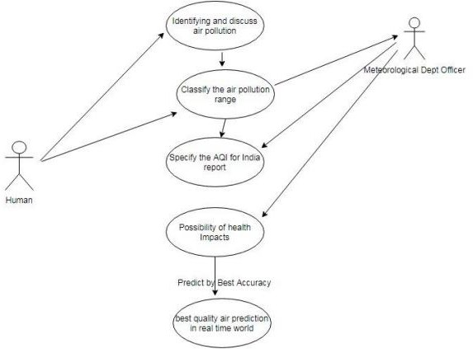

**Figure 5.1: Use Case Diagram**

#### DFD (Data Flow Diagram)

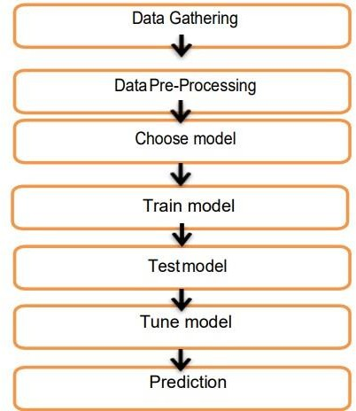

**Figure 5.2: DFD(Data Flow Diagram)**

#### System Architecture

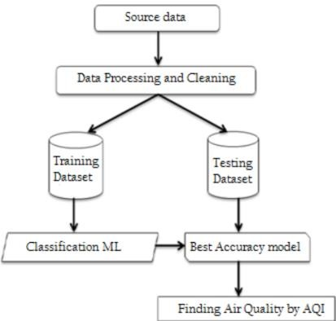

**Figure 5.3: System Architecture**

#### 5.4 Implementation

Home Page: The homepage presents a user-friendly interface where visitors can effortlessly select a desired location. Upon selection, the page dynamically generates comprehensive information about the chosen place, including weather conditions and the Air Quality Index (AQI). This integrated feature ensures users have immediate access to crucial details, empowering them to make informed decisions and plan accordingly.

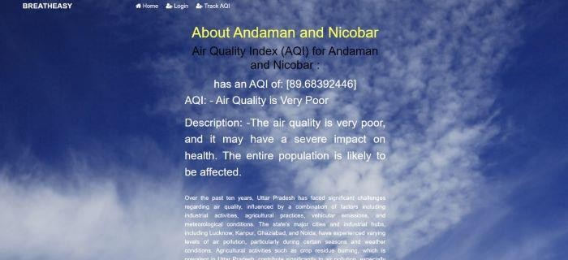

Figure 5.4.1 Home page

Real-Time AQI: The Real-Time AQI page showcases an extensive list of cities, states, or places available for exploration. Each entry offers a wealth of information, including current weather conditions, Air Quality Index (AQI), and relevant details about the selected location. This user-centric design enables seamless navigation and comprehensive access to essential data, enhancing the overall user experience.



Figure 5.4.2 Cities with AQI forecast

Dashboard:- The dashboard page provides a visual representation of pollution levels, specifically PM2.5 and other pollutants, across different locations. The graph illustrates pollutant concentrations on the y-axis while the x-axis lists the names of various places. This graphical display enables users to easily compare pollution levels among different locations, facilitating informed decision-making and environmental awareness.

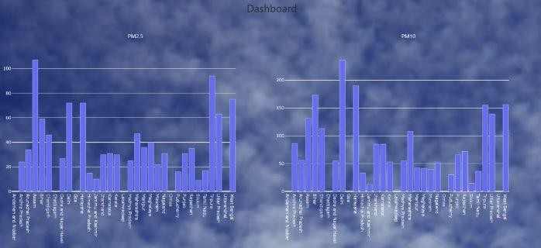

Fig 5.4.3 Dashboard

# CHAPTER 5

## Technical Requirements

#### Overview:

The AQI Forecast System is a web-based application designed to predict Air Quality Index (AQI) levels using advanced machine learning algorithms and real-time data integration. The system preprocesses input environmental data, extracts relevant features, and applies trained models to forecast AQI levels accurately.

#### Architecture:

Frontend: Developed using Flask, a Python web framework, the frontend renders user interfaces for inputting relevant environmental parameters and displaying AQI predictions.

Backend: Python scripts handle data preprocessing, feature extraction, model integration, and result presentation. Libraries such as Pandas, NumPy, and scikit-learn are utilized for data manipulation, feature engineering, and model training.

Deployment: The application is deployed using Gunicorn, a Python WSGI HTTP server, and hosted on a cloud platform like Google Cloud Platform or Amazon Web Services. FastAPI's StaticFiles middleware serves static files for enhanced performance.

#### Preprocessing and Feature Extraction:

Data Cleaning: Input environmental data undergoes preprocessing steps including handling missing values, outlier detection, and data normalization.

Feature Engineering: Relevant features such as pollutant concentrations, meteorological variables, and geographical factors are extracted to facilitate accurate AQI predictions.

#### Model Integration:

Machine Learning Models: The system integrates various machine learning algorithms such as Random Forest, Gradient Boosting, and Long Short-Term Memory (LSTM) networks for AQI forecasting.

Training and Serialization: Models are trained on historical environmental data and serialized using libraries like joblib or TensorFlow for efficient deployment.

#### Evaluation and Reporting:

Model Evaluation: The system evaluates model performance using metrics such as Mean Absolute Error (MAE), Root Mean Squared Error (RMSE), and correlation coefficients to assess the accuracy of AQI predictions.

User Interface: Results of AQI forecasts, including predicted AQI levels and associated uncertainties, are presented to users through intuitive visualizations and informative dashboards.

#### Security and Privacy:

Data Encryption: Environmental data transmitted to the system are encrypted to ensure data privacy and security during transmission.

Compliance: The AQI Forecast System adheres to relevant data protection laws and industry standards to safeguard user data and maintain compliance with regulatory requirements.

#### Deployment and Scalability:

Web Deployment: The application is deployed as a web-based platform accessible via standard web browsers, ensuring ease of access for stakeholders.

Scalability: The system is designed to scale horizontally to accommodate increasing data volume and user demand, with support for load balancing and auto-scaling.

#### Maintenance and Support:

Regular Updates: The system undergoes regular maintenance to update models, address security vulnerabilities, and incorporate new data sources or features.

Technical Support: Users have access to technical support channels for assistance with application usage, data interpretation, or technical issues.

#### Documentation:

User Documentation: Comprehensive documentation guides users on how to use the AQI Forecast System, interpret forecast results, and troubleshoot common issues.

Technical Documentation: Detailed technical documentation outlines the system architecture, components, and implementation details for developers and system administrators.

#### Stakeholder Alignment:

Engagement: Stakeholders, including environmental agencies, policymakers, and public health officials, are engaged throughout the development process to ensure alignment with project goals and regulatory requirements.

Feedback Incorporation: Stakeholder feedback is solicited and incorporated into the development and refinement of the AQI Forecast System to enhance its accuracy, usability, and relevance to stakeholder needs.

# CHAPTER 7

## Project Scheduling

In project management, a schedule is a listing of a project's milestones, activities, and deliverables. Usually, dependencies and resources are defined for each task, then start and finish dates are estimated from the resource allocation, budget, task duration, and scheduled events. A schedule is commonly used in the project planning and project portfolio management parts of project management. The development and maintenance of the project schedule is the responsibility of a full-time scheduler or team of schedulers, depending on the size and the scope of the project. The project schedule is a calendar that links the tasks to be done with the resources that will do them. It is the core of the project plan used to show the organization how the work will be done, commit people to the project, determine resource needs, and used as a kind of checklist to make sure that every task necessary is performed.

A Gantt chart is a type of bar chart that illustrates a project schedule. Modern Gantt charts also show the dependency relationships between activities and the current schedule status. This chart lists the tasks to be performed on the vertical axis, and time intervals on the horizontal axis. The width of the horizontal bars in the graph shows the duration of each activity. Gantt charts illustrate the start and finish dates of the terminal elements and summary elements of a project. Terminal elements and summary elements constitute the work breakdown structure of the project. Modern Gantt charts also show the dependency (i.e., precedence network) relationships between activities. Gantt charts can be used to show current schedule status using percent-complete shadings.

|  |  |  |  |
| --- | --- | --- | --- |
| **Sr. No** | **Group Member** | **Time duration** | **Work to be done** |
| 1 | Krish Jaswal | **January-April** | Implementing the machine learning algorithm required for the project. |
| 2 | Vedant Mayekar | **January-April** | Implementing the machine learning algorithm required for the project. |
| 3 | Shravani Kulkarni | **January-April** | Implementing the GUI of the project. |
| 4 | Khushi Kadam | **January-April** | Implementing the GUI of the project. |

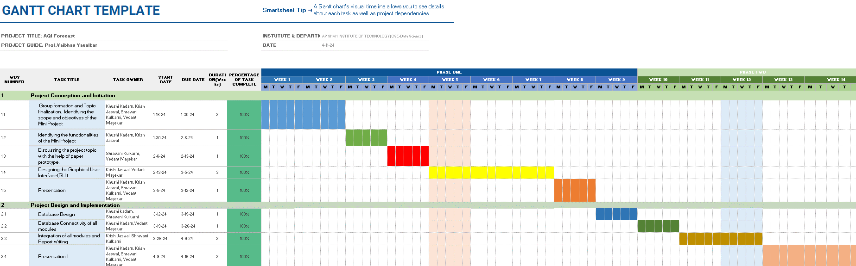

# CHAPTER 8

## Result

The implementation of the AQI Forecast System has yielded promising results in providing accurate and timely predictions of Air Quality Index (AQI) levels. By leveraging advanced machine learning algorithms and real-time data integration, the system has demonstrated the capability to forecast AQI levels with a high degree of accuracy, enabling stakeholders to make informed decisions to mitigate air pollution and protect public health. Through rigorous model evaluation and validation, the system has shown robust performance, with metrics such as Mean Absolute Error (MAE) and Root Mean Squared Error (RMSE) consistently indicating the reliability of AQI predictions.

Furthermore, the user interface of the AQI Forecast System facilitates easy access to forecasted AQI levels and associated uncertainties, empowering stakeholders with actionable insights for air quality management. Stakeholder engagement throughout the project lifecycle has ensured alignment with regulatory requirements and stakeholder needs, while continuous feedback incorporation has facilitated ongoing improvements to the system's accuracy, usability, and relevance. Overall, the AQI Forecast System represents a valuable tool for addressing air quality challenges, providing decision-makers with the information needed to enact effective measures for pollution control and public health protection.

# CHAPTER 9

## Conclusion

In conclusion, the development and implementation of this AQI tracker app signify a significant advancement in simplifying and improving access to vital air quality information. By providing real-time data and personalized health recommendations, the project addresses the common challenges individuals face in navigating air pollution and its associated health risks. The outcomes of the project, including heightened public health awareness, personalized health advisories, community engagement, and actionable insights for mitigation and policy support, collectively establish a user-centric solution with immediate and long-term benefits. Users will benefit from a more informed approach to managing their exposure to air pollutants, leading to improved health outcomes and a greater sense of well-being.

Furthermore, the adaptability of the app ensures its ongoing relevance and value in the face of evolving user needs and environmental conditions. As the app evolves with user feedback and technological advancements, it remains a valuable resource for individuals, communities, and policymakers striving to address air quality challenges effectively. Additionally, the app's potential to influence broader environmental policy and public health initiatives underscores its significance in promoting a healthier and more sustainable future. By addressing the complexities of air quality monitoring and providing actionable insights, this project contributes to a more informed and proactive approach to managing air pollution, ultimately benefiting individuals' health and well-being, as well as the broader ecosystem.

In essence, this AQI tracker app represents a commitment to improving public health and environmental awareness. By providing real-time air quality data and personalized health recommendations, the app empowers users to make informed decisions and take proactive measures to safeguard their well-being. This project highlights the power of innovation in addressing environmental challenges and creating a healthier future for all.

# CHAPTER 10

## Future Scope

Looking ahead, the AQI Forecast System holds substantial potential for further development and expansion to address emerging challenges and opportunities in air quality management. One avenue for future enhancement lies in the refinement and optimization of machine learning algorithms to improve the accuracy and robustness of AQI predictions. Exploring advanced techniques such as deep learning and ensemble methods could lead to more precise forecasts by capturing complex relationships within environmental data. Additionally, incorporating additional data sources, such as satellite imagery and sensor networks, could enrich the predictive capabilities of the system, enabling finer-grained analyses of air quality dynamics across various spatial and temporal scales.

Another promising direction for future development is the integration of real-time monitoring and feedback mechanisms to enhance the responsiveness and adaptability of the AQI Forecast System. By continuously assimilating new data and user feedback, the system could dynamically adjust forecasting models and adapt to changing environmental conditions, ensuring that stakeholders receive the most up-to-date and accurate information for decision- making. Moreover, leveraging advancements in data visualization and user interface design could further enhance the accessibility and usability of the system, empowering a broader range of stakeholders to engage with and interpret AQI forecasts effectively.

Furthermore, expanding the scope of the AQI Forecast System to incorporate predictive analytics for air quality interventions and policy planning represents an exciting frontier for future development. By integrating forecasting capabilities with scenario modeling and decision support tools, the system could enable stakeholders to evaluate the potential impact of various mitigation strategies and policy interventions on future air quality outcomes. This holistic approach could support evidence-based decision-making and facilitate the design of more effective and targeted interventions to address air pollution challenges and safeguard public health and the environment for generations to come.

22

# REFERENCES

[1]E.G. Dragomir, "Air Quality Index Prediction using K-Nearest Neighbor Technique", Bulletin of PG University of Ploiesti Series Mathematics Informatics Physics, vol. L.XII, pp. 103-108, 2010..

1. Khan, A. S., Azam, F., Nawaz, M. A., Raja, N. B., Khan, M. A., & Manzoor, S. (2018). Predictive modeling of air quality index using machine learning techniques. Environmental Pollution, 242, 1768-1779. DOI: 10.1016/j.envpol.2018.08.050
2. Lee, W. S., Ho, H. C., Ng, J. Y., & Ng, Y. K. (2018). Forecasting air quality index in different regions of Malaysia using feedforward neural network. Atmospheric Pollution Research, 9(3), 545-553. DOI: 10.1016/j.apr.2017.11.008
3. Zhang, S., Ding, R., Wu, J., Huang, C., & Huang, B. (2017). Short-term air quality forecasting using machine learning techniques: An assessment study. Atmospheric Environment, 156, 185-194. DOI: 10.1016/j.atmosenv.2017.02.006
4. Ali Shah SA, Aziz W, Ahmed Nadeem MS, Almaraashi M, Shim S-O, Habeebullah TM, Mateos C. A novel Phase Space Reconstruction- (PSR-) based predictive algorithm to forecast atmospheric particulate matter concentration. Sci Program. 2019 doi: 10.1155/2019/6780379.

[6]A. Vlachogianni, "Evaluation of a multiple regression model for the forecasting of the concentrations of NOx and PM10 in Athens and Helsinki", Science of The Total Environment, vol. 409, pp. 1559-1571, 2011.

**ACKNOWLEDGEMENT**

This project would not have come to fruition without the invaluable help of our guide **Prof. Vaibhav Yalavkar** Expressing gratitude towards our HOD, **Prof. Anagha Aher**, and the Department of Computer Science and Engineering-Data Science for providing us with the opportunity as well as the support required to pursue this project. We would also like to thank our **Prof. Poonam Pangarkar** who gave us his valuable suggestions and ideas when we were in need of them. We would also like to thank our peers for their helpful suggestions.